UPPER TUSCARORA PRESBYTERIAN CHURCH
Fourth Sunday after Epiphany
January 31, 2016

REV. DARWIN GOSHORN __________ PASTOR
PRELUDE
WELCOME AND ANNOUNCEMENTS
CALL TO WORSHIP
L: With what shall we come before God this day?
P: With love and justice, with compassion and kindness.
L: With what shall we worship the Lord this day?
P: With humility and mercy, with faithfulness and righteousness.
L: Come into God’s presence, not as perfect beings, but as people of hope and blessing.
P: Blessed are the poor in spirit. Blessed are the meek and merciful. Blessed are the sorrowful and those who dream of peace and righteousness.
PRAYER OF PRAISE AND ADORATION
*OPENING HYMN “Jesus Loves Me” #304
SILENT CONFESSION & PRAYER OF CONFESSION
God of hope and love, let your love shine upon us this day. Let your patience and kindness flow through us, inspiring us to new depths of love and hope. Transform our love, that we might overcome envy and resentment, and rejoice in justice and righteousness. Envelope us in your love, that believing, hoping, and enduring may become our way of life on the path of love. In loving hope, we pray. Amen.
ASSURANCE OF PARDON
*GLORIA PATRI
Glory be to the Father and to the Son and to the Holy
Ghost; As it was in the beginning, is now and ever shall be, world without end. Amen. Amen.
STATEMENT OF FAITH (Apostle’s Creed)
I believe in God the Father Almighty, Maker of heaven and earth, and in Jesus Christ his only Son our Lord; who was conceived by the Holy Ghost, born of the virgin Mary, suffered under Pontius Pilate, was crucified, dead, and buried; he descended into hell; the third day he rose again from the dead; he ascended into heaven, and sitteth on the right hand of God the Father Almighty; from thence he shall come to judge the quick and the dead. I believe in the Holy Ghost; the holy Catholic church; the communion of saints; the forgiveness of sins; the resurrection of the body; and the life everlasting. Amen.
PRAYER FOR ILLUMINATION
By your tender mercies, O God, by the unceasing ministry of your Spirit, open the meaning of the ancient documents handed on by communities of believers, so that in this time and place I may better understand how I may best work to heal your fractured world; in Jesus’ name. Amen.
TODAY’S SCRIPTURE READINGS
New Testament Lesson ~ 1 Corinthians 13:1-8, 13
Gospel Lesson ~ John 13:34-35
SERMON What Real Love Looks Like Rev. Goshorn
*HYMN OF THE DAY “Love Divine, All Loves Excelling” #376
SHARING OF JOYS AND CONCERNS
PASTORAL PRAYER AND THE LORD’S PRAYER
PRESENTATION OF OUR TITHES AND OFFERINGS
*DOXOLOGY
Praise God from Whom all blessings flow, Praise Him all creatures, here below; Praise Him above ye heavenly host, praise Father, Son and Holy Ghost. Amen.

*PRAYER OF DEDICATION
*CLOSING PRAYER
*CLOSING HYMN “More Love to Thee, O Christ” #359
*BENEDICTION
*POSTLUDE
* - Please stand, if YOU are able
All hymns are from the BLUE Hymnal

ANNOUNCEMENTS
NEXT SUNDAY – Transfiguration Sunday, February 7, 2016
ASH WEDNESDAY, February 10, 2016
UPCOMING GUEST PASTORS: Rev. John Dean (February 7), Rev. Darwin Goshorn (February 14).

THOUGHT FOR THE WEEK
John Calvin, French Reformer and Father of the Presbyterian Church (1509 – 1564): Baptism is the sign of initiation by which we are admitted into the fellowship of the church.

ON OUR PRAYER LIST:
Doris Shelton Dick Wagner Sopheia Abrashoff
Gary Ross Destiny Devlin Janet Jaymes Hornbaker
Gail Cresswell Julie Price Donna Varner Barney
Valerie Thomas Gail Corwell Colton Scott
Danny Gipe Shaun Wolford Family of Sylvia Cisney
Family of Ralph Swarner

OUR SERVICE PERSONNEL
Philip & Beth Locke Anthony Sheldon Todd Youtzy
Maddie Atherton Shae Greenland Nathan Parsons
Johnathan St. Clair Matthew Fontenot Eric Patterson
Donnie McAllen Zach Snyder Nathan Patterson
Kalib Yohn
Upper Tuscarora
Presbyterian Church
589 Brick Church Road
East Waterford, PA 17021
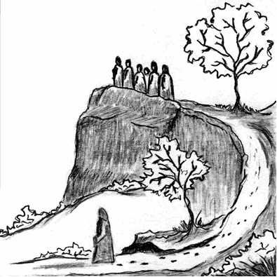
WELCOME!

January 31, 2016
Fourth Sunday after Epiphany

Rev. Darwin Goshorn Visiting Pastor

