UPPER TUSCARORA PRESBYTERIAN CHURCH
Second Sunday after Epiphany
January 24, 2016

REV. PAUL MARSTELLAR __________ PASTOR
PRELUDE
WELCOME AND ANNOUNCEMENTS
CALL TO WORSHIP
L: The One who created us, formed and made us, calls to us.
P: We are here to listen and respond.
L: God has claimed us and named us beloved.
P: We rejoice in this transforming identity.
L: Touched by the Spirit, washed in the renewing water, and set aflame with God’s love, let us worship and praise our beloved God.
PRAYER OF PRAISE AND ADORATION
*OPENING HYMN “Come, Thou Fount of Every Blessing” #356
SILENT CONFESSION & PRAYER OF CONFESSION
Loving God, it’s easy to feel superior to others, that our gifts make us better somehow. Center us in your love, that we may rejoice in the gifts of others. Ground us in your peace, that we may use your precious gifts to build a community of healing and hope, where justice is found, and where all walk in your ways. Amen.
ASSURANCE OF PARDON
*GLORIA PATRI
Glory be to the Father and to the Son and to the Holy
Ghost; As it was in the beginning, is now and ever shall be, world without end. Amen. Amen.

STATEMENT OF FAITH (Apostle’s Creed)
I believe in God the Father Almighty, Maker of heaven and earth, and in Jesus Christ his only Son our Lord; who was conceived by the Holy Ghost, born of the virgin Mary, suffered under Pontius Pilate, was crucified, dead, and buried; he descended into hell; the third day he rose again from the dead; he ascended into heaven, and sitteth on the right hand of God the Father Almighty; from thence he shall come to judge the quick and the dead. I believe in the Holy Ghost; the holy Catholic church; the communion of saints; the forgiveness of sins; the resurrection of the body; and the life everlasting. Amen.
PRAYER FOR ILLUMINATION
God, our guide and helper: In the scriptures you have given us the resources to find the way of life you intend for us. Now, by your Spirit’s faithfulness, enable us to understand this way without distortion, and to walk in it without timidity; through Jesus Christ our Savior. Amen.
TODAY’S SCRIPTURE READINGS
New Testament Lesson ~ 1 Corinthians 12:1-11
Gospel Lesson ~ John 14:15-17, 25-26
SERMON Who Got the Best Gift? Rev. Marstellar
*HYMN OF THE DAY “Holy Spirit, Truth Divine” #321
SHARING OF JOYS AND CONCERNS
PASTORAL PRAYER AND THE LORD’S PRAYER
PRESENTATION OF OUR TITHES AND OFFERINGS
*DOXOLOGY
Praise God from Whom all blessings flow, Praise Him all creatures, here below; Praise Him above ye heavenly host, praise Father, Son and Holy Ghost. Amen.

*PRAYER OF DEDICATION
*CLOSING PRAYER
*CLOSING HYMN “Breathe On Me, Breath of God” #316
*BENEDICTION
*POSTLUDE
* - Please stand, if YOU are able
All hymns are from the BLUE Hymnal

ANNOUNCEMENTS
NEXT SUNDAY – Transfiguration Sunday, February 7, 2016
ASH WEDNESDAY, February 10, 2016
UPCOMING GUEST PASTOR: Rev. Darwin Goshorn (January 31st).

THOUGHT FOR THE WEEK
Warren Wendel Wiersbe, American Pastor (b. 1929): The Christian life is not a playground, it is a battlefield.

ON OUR PRAYER LIST:
Doris Shelton Dick Wagner Sopheia Abrashoff
Gary Ross Shaun Wolford Janet Jaymes Hornbaker
Destiny Devlin Gail Cresswell Donna Varner Barney
Julie Price Valerie Thomas Gail Corwell
Colton Scott Danny Gipe

OUR SERVICE PERSONNEL
Philip & Beth Locke Anthony Sheldon Todd Youtzy
Maddie Atherton Shae Greenland Nathan Parsons
Johnathan St. Clair Matthew Fontenot Eric Patterson
Donnie McAllen Zach Snyder Nathan Patterson
Kalib Yohn

Upper Tuscarora
Presbyterian Church
589 Brick Church Road
East Waterford, PA 17021
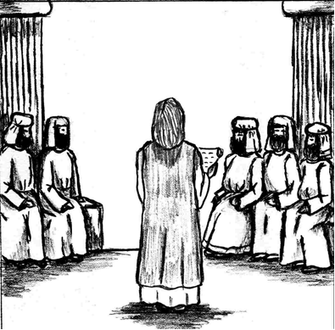
WELCOME!

January 24, 2016
Fourth Sunday after Epiphany

Rev. Paul Marstellar Visiting Pastor

