UPPER TUSCARORA PRESBYTERIAN CHURCH
Transfiguration Sunday
February 7, 2016

REV. JOHN DEAN_______ __________ PASTOR
PRELUDE
WELCOME AND ANNOUNCEMENTS
CALL TO WORSHIP
L: Worship the Lord with gladness; come before Him with joyful songs.
P: God has made us; we are His people.
L: Let us give thanks to God and praise His name!
P: For the Lord is good; His love endures forever.
PRAYER OF PRAISE AND ADORATION
*OPENING HYMN “O for a Thousand Tongues to Sing” #466
*SILENT REFLECTION AND PRAYER OF CONFESSION
Gracious God: our sins are too heavy to carry. Set us free from a past we cannot change. Help us to fully accept the forgiveness You offer this very day! Grant us grace to grow more and more into Your likeness, and courage to fulfill Your will. Open to us a future of renewed hope. We pray through Jesus, the light of the world. Amen.
*DECLARATION OF FORGIVENESS
Accept the wonderful news - you are forgiven, and be at peace!
*GLORIA PATRI
Glory be to the Father and to the Son and to the Holy
Ghost; As it was in the beginning, is now and ever shall be, world without end. Amen. Amen.
STATEMENT OF FAITH (Apostle’s Creed)
I believe in God the Father Almighty, Maker of heaven and earth, and in Jesus Christ his only Son our Lord; who was conceived by the Holy Ghost, born of the virgin Mary, suffered under Pontius Pilate, was crucified, dead, and buried; he descended into hell; the third day he rose again from the dead; he ascended into heaven, and sitteth on the right hand of God the Father Almighty; from thence he shall come to judge the quick and the dead. I believe in the Holy Ghost; the holy Catholic church; the communion of saints; the forgiveness of sins; the resurrection of the body; and the life everlasting. Amen.
PRAYER FOR ILLUMINATION
Guide us, O God, by your Word and Spirit, that in your light we may better understand what we read, that in your truth we find freedom, and in your will we discover real peace; Through Jesus Christ our Lord. Amen.
TODAY’S SCRIPTURE READINGS
Old Testament Lesson ~ Exodus 34: 29 -35
Gospel Lesson ~ Luke 9: 28 -43
SERMON This Light Of Mine Rev. Dean
*HYMN OF THE DAY “Master, Let Me Walk with Thee” #357
SHARING OF JOYS AND CONCERNS
PASTORAL PRAYER AND THE LORD’S PRAYER
PRESENTATION OF OUR TITHES AND OFFERINGS
*DOXOLOGY
Praise God from Whom all blessings flow, Praise Him all creatures, here below; Praise Him above ye heavenly host, praise Father, Son and Holy Ghost. Amen.
*PRAYER OF DEDICATION
Blessed are You, God of all creation. Accept and use our offerings for Your glory and for the service of Your kingdom. Amen.

*CLOSING PRAYER
*CLOSING HYMN “Lord, Dismiss Us with Thy Blessing” #538
*BENEDICTION
*POSTLUDE
* - Please stand, if YOU are able
All hymns are from the BLUE Hymnal

ANNOUNCEMENTS
ASH WEDNESDAY, February 10, 2016
UPCOMING GUEST PASTORS: Rev. Darwin Goshorn (February 14).

THOUGHT FOR THE WEEK
John Calvin, French Reformer and Father of the Presbyterian Church (1509 – 1564): Baptism is the sign of initiation by which we are admitted into the fellowship of the church.

ON OUR PRAYER LIST:
Doris Shelton Dick Wagner Sopheia Abrashoff
Gary Ross Destiny Devlin Janet Jaymes Hornbaker
Gail Cresswell Julie Price Donna Varner Barney
Valerie Thomas Gail Corwell Danny Gipe
Shaun Wolford Jen (Missionary) Gary & Sandy Dinsmore
Charles Kline Family of Norman Burdge

OUR SERVICE PERSONNEL
Philip & Beth Locke Anthony Sheldon Todd Youtzy
Maddie Atherton Shae Greenland Nathan Parsons
Johnathan St. Clair Matthew Fontenot Eric Patterson
Donnie McAllen Zach Snyder Nathan Patterson
Kalib Yohn

Upper Tuscarora
Presbyterian Church
589 Brick Church Road
East Waterford, PA 17021
And when the Voice had spoken,
Jesus was found alone.
And when the Voice had spoken,
Jesus was found alone.
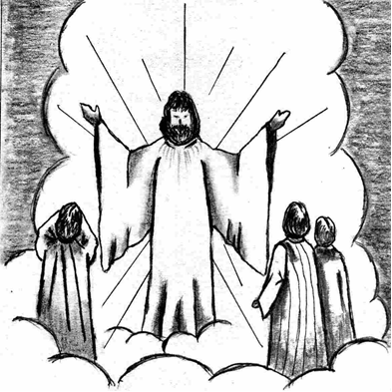
WELCOME!

February 7, 2016
Transfiguration Sunday

Rev. John Dean Visiting Pastor

