UPPER TUSCARORA PRESBYTERIAN CHURCH
First Sunday of Lent
February 14, 2016

REV. DARWIN GOSHORN __________ PASTOR
PRELUDE
WELCOME AND ANNOUNCEMENTS
CALL TO WORSHIP
L: We have come at Jesus’ bidding, to witness and understand.
P: We have been called by the transfiguring God to live lives of
service. We see. We listen. We understand.
L: Let our worship reflect the glow we witness, that God’s light, shining within us, might be a beacon to a world lost in darkness.
P: Let our light shine so that all can see and be led to the God of love and peace.
PRAYER OF PRAISE AND ADORATION
*OPENING HYMN “A Mighty Fortress Is Our God” #260
SILENT CONFESSION & PRAYER OF CONFESSION
Change our hearts, O God. Renew us with your Spirit of love and grace. Wash away the dust and ashes that cloud our vision and burden our lives. Guide us back to you, that we may refocus once more, and rest anew in the treasure of your love. In your holy name, we pray. Amen.
ASSURANCE OF PARDON
*GLORIA PATRI Please refer to laminated page in pew
*APOSTLE’S CREED Please refer to laminated page in pew
PRAYER FOR ILLUMINATION
Author of grace, and our Eternal Guide: As we make our pilgrimage through this life, shed your light upon our way, lest we slip or go astray. Speak to us in the recorded witness of synagogue and church that through the Spirit’s interpretation of the Scriptures we may find direction and strength; through Christ Jesus, the Shepherd of our souls. Amen.
TODAY’S SCRIPTURE READINGS
New Testament Lesson ~ Luke 4:1-13
Gospel Lesson ~ Matthew 16:21-23
SERMON Temptations of Jesus Rev. Goshorn
*HYMN OF THE DAY “Lord, I Want To Be A Christian” #372
SHARING OF JOYS AND CONCERNS
PASTORAL PRAYER AND THE LORD’S PRAYER
PRESENTATION OF OUR TITHES AND OFFERINGS
*DOXOLOGY Please refer to laminated page in pew
*PRAYER OF DEDICATION
INVITATION TO THE SERVICE OF COMMUNION
*COMMUNION HYMN “In Christ There is no East or West” #439
SERVING OF THE ELEMENTS
*CLOSING HYMN “O Jesus, I have Promised” #388
*BENEDICTION
*POSTLUDE
* - Please stand, if YOU are able
All hymns are from the BLUE Hymnal

The Gloria Patri, Doxology, Apostle’s Creed and Lord’s Prayer have now been printed, laminated and placed in the pews for your convenience for each week’s services.

ANNOUNCEMENTS
UPCOMING GUEST PASTORS: Rev. Darwin Goshorn (February 21, March 13 and March 20).

THOUGHT FOR THE WEEK
Carlo Carretto, Cardinal (1454 – 1514): Optimism means faith in men, in their human potential; hope means faith in God and his omnipotence.

ON OUR PRAYER LIST:
Doris Shelton Dick Wagner Sopheia Abrashoff
Gary Ross Destiny Devlin Janet Jaymes Hornbaker
Gail Cresswell Julie Price Donna Varner Barney
Valerie Thomas Gail Corwell Danny Gipe
Shaun Wolford Jen (Missionary) Charles Kline
Family of Norman Burdge Gary & Sandy Dinsmore

OUR SERVICE PERSONNEL
Philip & Beth Locke Anthony Sheldon Todd Youtzy
Maddie Atherton Shae Greenland Nathan Parsons
Johnathan St. Clair Matthew Fontenot Eric Patterson
Donnie McAllen Zach Snyder Nathan Patterson
Kalib Yohn

CONGREGATIONS TO PRAY FOR
Bellefonte -- Rev. Joy Kaufmann, Moderator
Birmingham – Rev. John Dean, Moderator

Upper Tuscarora
Presbyterian Church
589 Brick Church Road
East Waterford, PA 17021
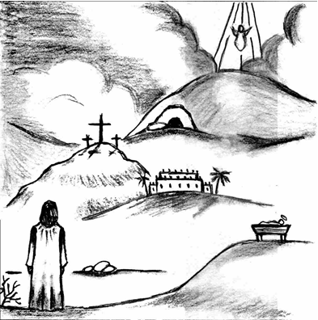
And when the Voice had spoken,
Jesus was found alone.
And when the Voice had spoken,
Jesus was found alone.
WELCOME!

February 14, 2016
First Sunday of Lent

Rev. Darwin Goshorn Visiting Pastor

